IPTC DDTS Mona
Description
An Ericsson Digital Telephone Set (DTS) Compatible Module
Features
- TI 16-bit fixed-point Digital Signal Processor (DSP) ranging from 120 to 160 MIPS, and with 64 to 256 kB 0ws SRAM (standard TMS320VC5409A; optional 5410A, 5416)
CPU & Memory
- SPI Serial EEPROM for firmware (standard 32-64 kB)
- Microwire Serial EEPROM for configuration data (standard 512 bytes)
- Extension line 2B+D protocol implemented in DSP on the top of NS TP3406V DASL
Protocol
- Emulation of DBC213 (or any other DBC and OPI II console as a skin)
- Transparent connectivity to Ericsson MD110 / Business Phone (Fenix)
- Echo cancellation and voice processing algorithms implemented in DSP
- TI 16-bit audio CODEC with programmable gain and 89dB SNR (TLC320AD50)
Audio
- Bridge-Tied Load audio amplifier (TPA701: 0.7W at 8Ω; optional TPA6211A1: 3.1W at 4Ω)
- Microphone preamplifier (40-58dB) with shadow power supply for electret microphones
- I/O Expansion with 5 TTL inputs, 8 TTL outputs (±24mA) and power supply terminal
I/O
- Plug-in support for 4 LEDs and 5x8 matrix keyboard
- HD4470 compatible LCD display option with PWM background light
- Industrial Temperature Operating Environment –20ºC … +70ºC
- Hardware watchdog with power supply supervision
- Power supply with wide-range input 9-60VDC / 12-36VAC providing up to 2A at 5V
Robustness
- Power supply from PBX, if the power consumption is less then 75mA (at 30-60V)
- Two-stage soft-start power supply keeping start-up in-rush current below 100mA
- Typical power consumption 1.5 W
- Special door-telephone features: remotely controllable relay switch with max 1A load at 30VDC, and case intrusion detection
Misc
Applications
Embedded Digital Telephone Set Module, e.g.:
- Digital Door Telephone Set
- Digital Conference Telephone Set
- Voice Over IP Gateway/Extender DTS
Custom Design Options
- Board layout
- I/O expansion
- Audio amplifier
- DSP Enhanced Host-Processor Interface (HPI) 8/16-bit connection

Block Diagram

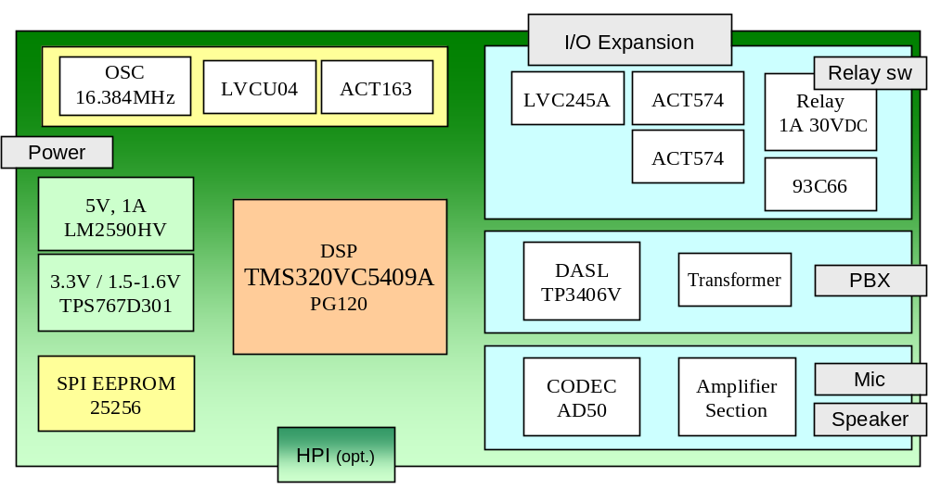
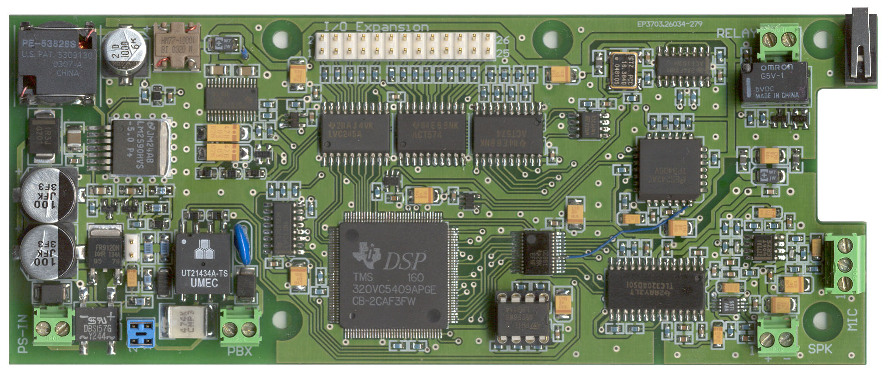
Power Supply
DASL front
Boot EEPROM
Config EEPROM
Time
Base
I/O Interface
Relay
Intrusion Switch
Audio Interface
DSP
DASL
PS in
66
157
PBX
SPK
MIC

Connector Description

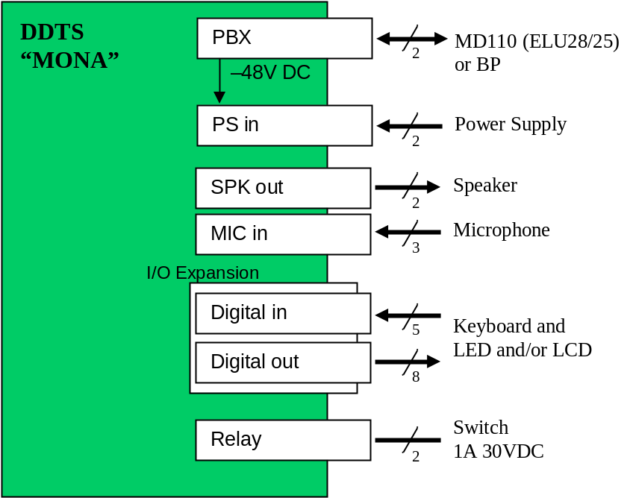

Connector | Description
PS in | Input power supply 9-60VDC / 12-36VAC
PBX | Connected to ELU 28
MIC | Electret microphone input
SPK | BTL speaker output
Relay | 1A 30VDC switch
I/O Expansion | 5 TTL inputs, 8 TTL outputs (±24mA)  - direct connection for 4 LEDs  - keyboard with up to 5x8 keys  - LCD HD4470 compatible (in 4-bit mode)

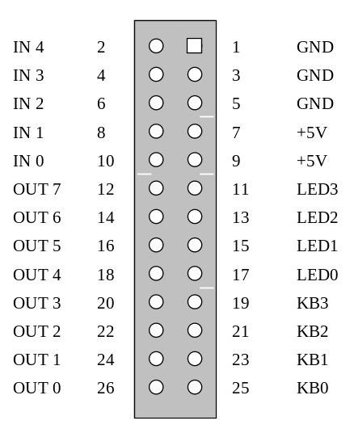
I/O Expansion Connector Description

Features in Details
- TI fixed point Digital Signal Processor (DSP) ranging from 120 to 160 MIPS, and from 64 to 256 kB 0ws SRAM (standard TMS320VC5409A; optional 5410A, 5416)
  - The TMS320C54x DSP generation is featuring a broad product lineup of 15 distinct devices with performance ranging from 30 to 532 MIPS. The architecture and instruction sets of the C54x enables extremely small code size for DSP functions, allowing the DSPs to take maximum advantage of on-chip RAM.
  - Devices in used in DDTS Mona design are with the following characteristics in brief
MHz | 120 – 160
MIPS | 120 – 160
Active Power | 40 – 90 mW
Pricing (1kU) | $11.15 – $25.57 US
Peripherals | 3 McBSP, 8/16-bit HPI, 6-channel DMA

  - Options:
TMS320VC5409APGE120 120 MIPS 64kB RAM $11.15 Default choice
TMS320VC5409APGE160 160 MIPS 64kB RAM $12.73
TMS320VC5410APGE120 120 MIPS 128kB RAM $13.81
TMS320VC5410APGE160 160 MIPS 128kB RAM $15.31
TMS320VC5416PGE120 120 MIPS 256kB RAM $23.01
TMS320VC5416PGE160 160 MIPS 256kB RAM $25.57
- SPI Serial EEPROM for firmware (standard 32-64 kB)
  - 8-pin DIL package placed in socket
  - Boot time is below 4 seconds
  - Options:
M95256 or AT25256 32kB Default choice
AT25H512 64kB
- Microwire Serial EEPROM for configuration data (standard 512 bytes)
  - Standard 256 x 16 bit storage for storing configuration data, when needed
  - Options:
M93C66 256 x 16 Default choice
M93C86 1k x 16
- Extension line 2B+D protocol implemented in DSP on the top of NS TP3406V DASL
  - Digital Adapter for Subscriber Loops (DASL) with range up to 800 meter on #24 cable
  - Fully compatible client-side of Ericsson extension line 2B+D protocol
  - Input overvoltage transient protection with both fast TVS diode and metal-oxide varistor
- Emulation of Ericsson DBC213 (or any other DBC and OPI II console as a skin)
  - Emulation of DBC213 having 3 x 40 character display and two rows function keyboard
  - Possible emulation of any other DBC, even OPI II console
  - Buttons are programmable in PBX, which makes easy remote setup of the DTS
  - Events could be connected to some actions like ringing of ADN to switch relay on
- Transparent connectivity to Ericsson MD110 / Business Phone
  - Connectible both to MD110 or Business Phone (Fenix) Ericsson PBXs
- Echo cancellation and voice processing algorithms implemented in DSP
  - Base system CPU usage is maximum 12 MIPS giving minimum 90 MIPS available for voice and audio processing algorithms on the 120MHz DSP
  - Easy upgreadable acoustic (32 MIPS) and network (11 MIPS) echo cancellation algorithms
  - DTMF receiving and transmission (3 MIPS)
  - Automatic gain control
  - 40 MIPS available for future extensions like noise reduction etc.
- TI 16-bit audio CODEC with programmable gain and 89dB SNR (TLC320AD50)
  - 16-bit oversampling sigma-delta ADC and DAC with 22.05 kHz max. sampling rate
  - Typical 89 dB signal-to-noise ratio (SNR) for ADC and DAC
  - Typical 90 dB signal to total harmonic distortion (THD)
  - Typical 88 dB dynamic range
  - Programmable input and output gain control
- Bridge-Tied Load (BTL) audio amplifier
  - Speaker connected in Bridge-Tied Load configuration ensures 5V single power operation
  - Shutdown option with fast startup
  - Output power options:
TPA701 700mW for R_{L} = 8 Ω at THD 0.5%, 250 mW for R_{L} = 50 Ω Def. choice
TPA6211A1 3.1W for R_{L} = 3 Ω at THD 10%
- Microphone preamplifier (40-58dB) with shadow power supply for electret microphones
  - Fixed 40 dB preamplifier gain with differential ouput
  - Additional 6, 12 or 18 dB gain settable in CODEC
- I/O Expansion with 5 TTL inputs, 8 TTL outputs (±24mA) and power supply terminal
  - 5x low-voltage TTL compatible inputs
  - 8x TTL outputs capable to sink/drive 24mA
  - +5V power supply terminal
- Plug-in support for 4 LEDs and 5x8 matrix keyboard
  - 4x pull-up resistors for LED
  - 4x schottky diodes providing easy matrix keyboard connection
- HD4470 compatible character LCD display option with PWM background light
  - Option to connect HD4470 compatible character LCD display in 4-bit mode
- Industrial Temperature Operating Environment –20ºC … +70ºC
  - Satisfies out-door environment requirements for door telephones
- Hardware watchdog with power supply supervision
  - The system is reset (rebooted) if the software does not response in 2 seconds
  - The system is reset if the power supply drops below a certain limit
  - Total out-of-service time is maximum 6 seconds: 2s for watchdog detection and 4s to boot
  - Voice connection will persist while the system is rebooting or is temporary not operative
- Power supply with wide-range input 9-60VDC / 12-36VAC providing 1-2A at 5V
  - Wide-range power supply input with undervoltage and overvoltage-transients protection
  - Additional ripple-suppression post-filter provides output voltage with negligible ripple
  - DDTS draws itself max 170 mA at 5V, which gives 800–1800 mA available for external applications
  - Options:
LM2590HV 5V, 1A output Default choice
LM2593HV 5V, 2A output
- Power supply from PBX, if the power consumption is less then 75mA (at 30-60V)
  - Up to 75mA can be drawn directly from PBX line by the power supply; Limit is imposed by the DASL wet-transformers which tolerates maximum 75mA DC
- Two-stage soft-start power supply keeping start-up in-rush current below 100mA
  - PBX has protection to automatically power off DTS if it draws current more than 100mA
  - The system complies to this limit in all conditions, even during start-up
- Typical power consumption 1.5 W
  - Power supply efficiency is min. 53% with consumption 5V 160mA, max. 79% with consumption 5V 2A
- Special door-telephone features: remotely controllable relay switch with max 1A load at 30VDC, and case intrusion detection
  - Remotely controllable relay switch with max 1A load at 30VDC, e.g. triggered when ADN on DTS is being called or specific number is calling DTS
  - Case intrusion switch could be set to automatically dial predefined number (remotely configured in PBX)
Custom Design Options
- I/O expansion
  - I/O expansion is adjustable to customer needs
- Audio amplifier
  - Microphone preamplifier and speaker amplifier sections are adjustable to customer needs
- Board layout and embedded module options
  - Board layout and dimensions are adjustable to customer needs
  - Device is available as embedded module for other designs (both schematic and PCB)
- DSP Enhanced Host-Processor Interface (HPI)
  - 8/16-bit Enhanced Host Port Interface (EHPI) for communication with a external general-purpose processor. Multiple DSPs could be connected to a single EHPI bus.
  - Parallel port for host processor to directly access DSP's memory space
  - Configure DSP memory access for either Host Only Mode (HOM) or Shared Access Mode (SAM)
  - Host & DSP can exchange information via internal/external memory
  - Access to entire DSP internal memory

